RC Car:
Automated Lighting & Horn System

By: Eli Gabaldon, Olasubomi Borishade & Robert Valois

Department of Electrical Engineering
University of North Texas, Discovery Park

EENG 3910.001 - Embedded Systems Design Project
Dr. Xinrong Li & Masleh Uddin Siddiqui
December 11th, 2023

Table of Contents
Abstract………………………………………………………………............................................
Introduction………………………………………………………………………..........................
Background & Theory……………………………………………………………..........................
Design Implementation………………………………………………………………………….....
Testing & Results……………………………………………………………….............................
Conclusion………………………………………………………………………............................
References……………………………………………………………………….….......................

Abstract
In this project, we are using a Bluetooth-connected remote-controlled car’s drive and turn motors as inputs to control the car's turn signals, horns, and headlights. The project requires creative applications of timers and interrupts, working around the Nucleo-board's current restrictions and ensuring that these integrated functions work in parallel (simultaneously).

Introduction
In our EENG 3910 class, all students have been introduced to the concept of embedded systems design using STM32 development tools by STMicroelectronics. We’ve been programming the MCU in C language and utilizing specific functions that interface with our Nucleo Board. Over the course of the semester, we have covered topics specific to the MCU and the Nucleo Board like its GPIO layout and pin mapping, as well as general embedded system concepts like timers/interrupts, serial communication (UART), AD/DA conversion, PWM, etc. We programmed the MCU to execute specific functions on the Nucleo-board's built-in components like its buttons and LEDs, but we also prototyped simple external circuits on our breadboards which were controlled by the MCU. This project is a culmination of all the knowledge gained during the course of the semester.
In deciphering a fun way of incorporating a lot of what we’ve learned, we resolved to using a Bluetooth-connected remote-controlled car’s drive and turn motors as inputs to automate the car's lighting system and horn. Not only does this include the major topics we learned in EENG 3910, but it also gave us a chance to provide Robert’s son with a more fun car to play with.
Initially, we had decided to use a Bluetooth low-energy expansion module with our Nucleo-board, seeing that we had all expressed interest in using bluetooth for other personal projects. This method would have us receive the bluetooth data as inputs instead of the car’s motors directly, giving us a larger set of different (possibly more precise) inputs that we could use for our system control logic. We toiled to review the documentation of the old video game controller and create communication between it and the BLE-1 module. Unfortunately, it seemed as though we had hit a brick wall and our time was very much limited. Thus, we settled for direct communication between the car and the Nucleo-board.
Before we move on to the design and implementation section of this report, it is key that we highlight some important information on the MCU, the Nucleo-board's operation as well as the different communication protocols/interfaces that we employ.

Background & Theory
An embedded system is any device that includes a programmable computer but is not a standalone/general-purpose computer in itself . Embedded computing system design is a valuable skill for many types of product design. Many household appliances, mobile phones, vehicles, and many others rely on the use of embedded system design. We refer to the computers within these appliances as microprocessors. Microprocessors implement digital systems and make it easier to design families of products that can be built to provide various feature sets. Moreover, they are easy to adapt to the demands of consumers.
The STM32 family of 32-bit microcontrollers (MCU) are based on the ARM Cortex-M processors. The Nucleo-L476RG is a Nucleo-64 ultra-low power board consisting of an ST-Link block on the top part (with USB communication) and the MCU part with built-in hardware components like buttons and LEDs. This board has 64 pins, with 51 of them being general purpose. These pins can be configured as digital I/O, analog input, or they can have alternative functions such as DAC, SPI, USB, PWM, etc.
An important part of the MCU is its built-in timers. A timer is a piece of hardware within the MCU that acts like a free-running counter, counting pulses from a clock source. When the period of the clock source is known, the elapsed time can be determined accurately from the clock pulse counter. The clock source for a timer is derived from the MCU clock and can be configured on our GPIO configuration tab in the IDE. We can further manipulate this time by what we call a prescaler, which divides the clock source by the amount we give it. We can use these timers to access the MCU memory (DMA), sampling incoming signals in the AD process, the implementation of DA conversion, etc. The use of timers in the memory access scheme is important in our project. We were able to do this using what we call an interrupt.
An interrupt requests that the CPU halt its current task to execute another. As soon as this is done, it returns back to the main application. Because the interrupt enforces only one code to run at that instant in time, it is called asynchronous. The code that the interrupt jumps to when called is known as the Interrupt Service Routine or ISR. Since interrupts are asynchronous, they operate in order of priority. There are 16 levels of priority on our board. Also, there are internal and external interrupts which we can discern by the interrrupts trigger source: the STM32L476 processor has 23 external interrupt sources. We can use interrupts generated by timers to run a periodic subroutine through the timer interrupt handler. This is how we run schemes like the DMA.
On the foundation of asynchronous interrupts, we also have asynchronous communication like the UART protocol. It is a form of serial communication – the means by which data is transmitted across long distances in the most efficient/dependable manner. UART means Universal Asynchronous Receiver-Transmitter communication. Two widely accepted standards of this serial communication are the RS232 and RS485. The RS232 standard is mainly used for shorter distances and just one device on its network. The RS485 line, on the other hand, can accommodate long distances and multiple devices on a single network.
Data is sent across these lines at a specific rate called the Baud rate. Typical Baud rates are 4800, 9600, 19200, and 38400. Data is transmitted and received in what is called a ‘frame’, which typically consists of a start bit, 8 data bits, and a stop bit (i.e., 10 bits in total transmit a byte). Since this process is asynchronous, it stops whatever program is running to transmit/receive data-based on the point at which it is called. We didn’t exactly employ UART in our project or the design procedure, but it is a great example of what an asynchronous interrupt is like.
An integral part of this project was the use of PWM or Pulse-Width Modulation. PWM can be described as a way digital pulses can control analog signals. PWM is likened to a form of modulation in which the carrier signal is digital, and the message/information is analog. The PWM method is used in applications where we’d like to control the average power delivered to a load. This application is achieved by switching the amplitude of a digital signal (pulsating) between a high and low state with a switching period/frequency high enough that the load doesn’t recognize/get affected by it. The power output of the analog signal delivered to the load only changes when the digital pulse is high, creating the effect of the analog signal being sampled/quantized.
The frequency of the PWM is determined by the ‘duty cycle’. The duty cycle describes the proportion of time the signal is in its high state in comparison to its low state. For example, when the signal is high for the same amount of time it is low; we call that a 50% duty cycle. The percentage value widely chosen is that for the time spent on: if the signal is high for 25% of the time, we call it a 25% duty cycle. The internal clock that generates these digital pulses determines the rate at which the signal switches between the on and off state. The quicker the time, the smoother the load control (to an extent). The slower it is, the more likely it is to create oscillations in the output of the load (e.g., visible flickering in an LED).
Pulse-width modulation is used in controlling the speed of electric motors, regulating the brightness of LEDs (as we will see in today’s assignment), encoding messages, audio amplification, etc. In this project, we utilize the internal timer/clock system in our MCU to generate a PWM waveform and adapt it to control our piezoelectric buzzer (horn). Now that we have the foundational topics covered this semester, we can advance to the design and implementation section.

Design Implementation
The RC car used in this design is a Jada Hyperchargers 2017 Ford GT, pictured in Figure 1. The car has two motors, one at the front of the car and one at the back of the car. The motor at the front of the car controls the steering, by turning the front wheels left or right. The motor at the back of the car drives the car either forward or reverse. The controller has four discrete inputs. The left stick can be pressed up or down, this drives the car in forward or reverse. The right stick can be pressed left or right, this steers the front wheels left or right.
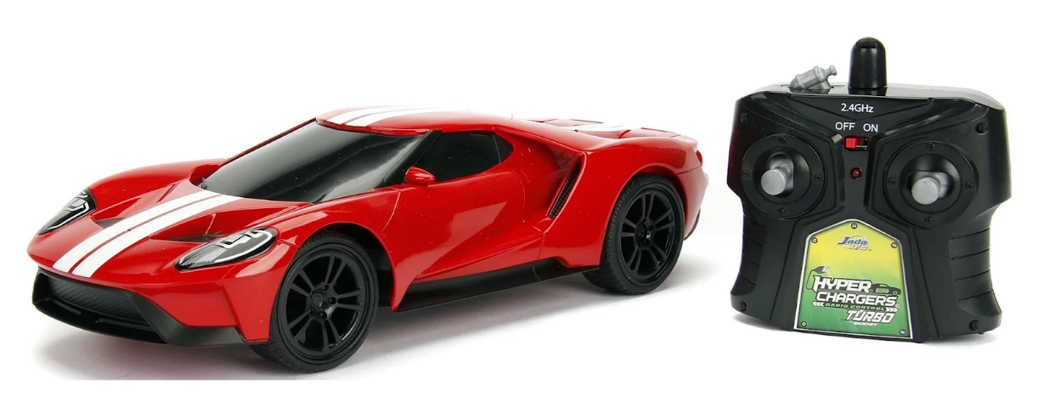
Figure 1: https://www.walmart.com/ip/Jada-Toys-Hyperchargers-1-16-Big-Time-Muscle-RC-2017-Ford-GT/815595593
The goal of the project is to add the following features to remote control car:
- Headlights
- Brake lights
- Turn signals
- Car horn

Figure 2 is a diagram outlining how the project goals were accomplished.
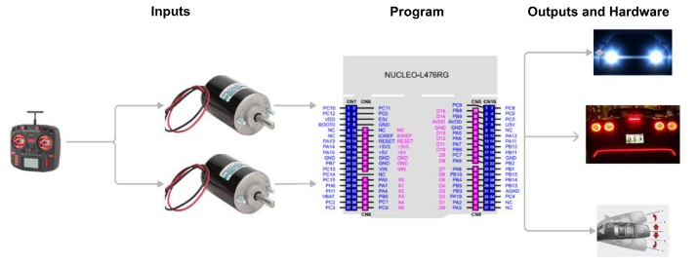
Figure 2: Design Signal Flow Diagram

Inputs
The first step in accomplishing the project goals is to identify potential input signals that may be used to control the functions. We used a multimeter to check for signals on the car's existing circuitry. We found that one of the four motor leads will read 2.5V, in reference to the negative car battery terminal, when one of the controller inputs is pressed. The remaining three motor leads read 0V. Figure 3 shows the four motor leads and indicates which lead is energized when the associated controller input is pressed. We soldered wires onto the motor leads. These wires will connect to I/O pins on the Nucleo-L476RG.
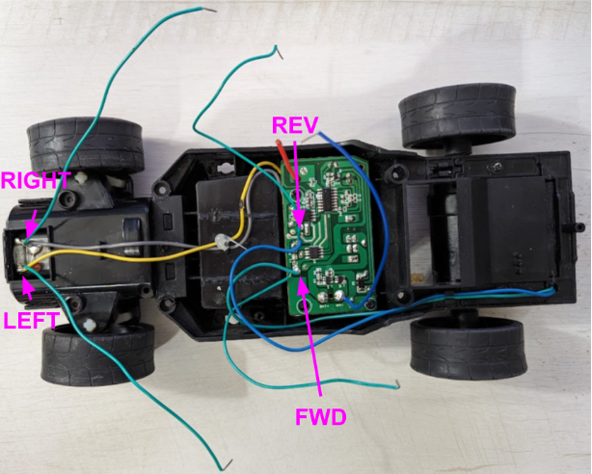
Figure 3: RC Car Circuitry

We made a simple test program using the Nucleo-L476RG to determine if the 2.5V from one of the motor leads would be read as a logical HIGH by the STM32L476 processor. After confirming that 2.5V would generate a logical HIGH, we moved on to fitting the car body with the necessary hardware and programming the STM32.
Outputs and Hardware
We had hardware on hand from previous classes and hobbies to implement each of the functions outlined in our project goals. The headlights, brake lights and turn signals are 5mm LEDs. The LEDs each have a maximum current of 20mA. We wanted our LEDs to be brightly lit, so we needed to operate them near the maximum rating.

The horn is a passive buzzer. We found that applying a 400 Hz 9V square wave our passive buzzer would produce a car horn like sound. We measured a current of 56mA through the passive buzzer when our test signal was applied.
Figure 4 shows a table taken from the STM32L476 datasheet. It outlines the current characteristics of the STM32L476 microcontroller. We intended to operate each of our LEDs near the maximum rated current for any one I/O pin. All of the LEDs were to be operated in pairs, meaning we would exceed the rated current if one pair of LEDs was powered by an I/O pin. The passive buzzer required more voltage than the 3.3V the I/O pins could provide. For these reasons we needed to make an external circuit with its own power supply that could be controlled by the STM32L476 I/O pins.

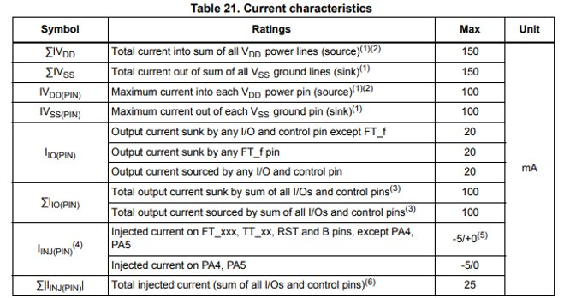Figure 4: STM32L476xx Datasheet Section 6.2 [2]
Figure 5 is a schematic of the external circuit made to supply power to the LEDs and buzzer. The schematic shows a 9V battery connected to the collector 5 BJT transistors. The emitter of each transistor connects to either a pair of LEDs or the passive buzzer. General purpose I/O (GPIO) pins connect to the base of each transistor. This schematic only shows one GPIO source, in practice each BJT base pin is connected to a different GPIO pin. The base pin of the BJT used for the passive buzzer is controlled by an STM32L476 pin that can perform pulse width modulation (PWM). The schematic also shows that the 9V battery is connected to the Nucleo-L476RG Vin pin. This pin accepts a range of 7v to 12V, then the Nucleo board power management circuitry reduces the voltage and powers the STM32L476 [3].

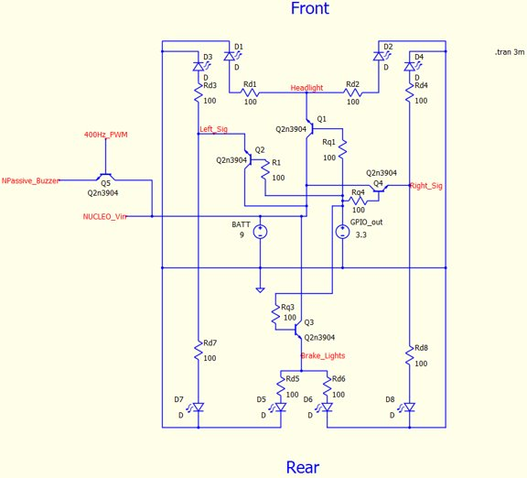
Figure 5: Hardware Schmatic
Figure 6 is a photo of the cars circuitry connected to the Nucleo board inside the body of the car.
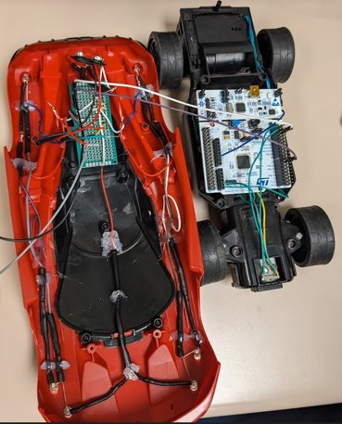
Figure 6: Photo of Inputs, Nucleo board, and Outputs Fit to Car Body

STM32 Program
The STM32 program had to make use of the four available inputs, while not interfering with the inputs primary functions. The primary functions of the inputs are to drive and steer the car. Our team decided that double tapping any direction on the car controller would generate a signal that may be used as an input to the STM32 without interfering with the driving and steering of the car. Each team member tested the speed of their double tap on the car controller. We found that we all could double press an input consistently in less than 300 ms. Figure 7 is a table of the sequence of inputs we assigned to each function listed in the project goals.

Toggle Headlights | UP, UP in less than 300 ms
Sound Horn | DOWN, DOWN in less than 300 ms
Start/Stop Left Turn Signal | LEFT, LEFT in less than 300 ms
Start/Stop Right Turn Signal | RIGHT, RIGHT in less than 300 ms
Brake Lights On | Neither UP nor DOWN pressed
Figure 7: Car Functions and Controller Sequences
Figure 8 shows the STM32 I/O pins we chose to use for our program. After selecting I/O pins we configured the four GPIO input pins to trigger external interrupts. Then we configured 3 timers needed to carry out our program. The first timer, TIM1, was set to a pulse width modulation of 400Hz and is used for the car horn output. The second timer, TIM2, has a period of 300 ms. It is used for timing the duration between user inputs into the car’s controller. The last timer, TIM3, has a period of 500ms. It is used to control the rate at which the turn signals flash. Timer interupts are enabled for TIM2 and TIM3.
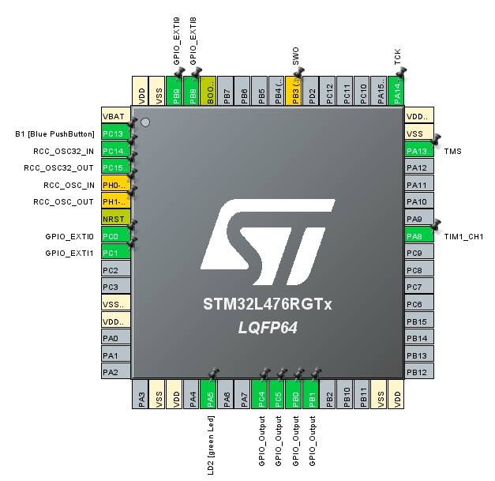
Figure 8: STM32 I/O Pin Assignments

Our code is submitted in a seperate file titled “RC_AUX.c”. In the app initialization the TIM3 inturupt is started and the duty cycle of the TIM1 PWM is set to 50%.
In the main loop the program checks if the inputs associated with the foward/reverse motor are HIGH. If neither input is HIGH the brake light output is set HIGH. Otherwise the brake light output is set low.
The remainder of the main loop is a switch case that takes the input RC_Input. The variable RC_Input may be set to HORN, HEADLIGHTS, RIGHT_TURN, or LEFT_TURN. If RC_Input is set to one of these values, then the program will perform the function listed in Figure 7.
The value of RC_Input is set when two external inturupts that are associated with the same user input occur within 300 ms. This is accomplished by starting the TIM2 inturrupt immediatly after the external interupt is triggered. The second external inturrupt will only change the value of RC_Input if the TIM2 timer has not yet expired. The program also uses TIM2 in ensure that two inputs are at least 100 ms apart. This reduces the registering of inputs that were not intended by the user. Figure 9 shows how this idea was used to change the value of RC_Input to HEADLIGHTS.
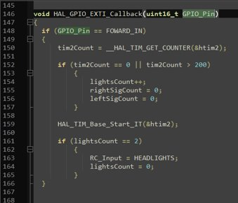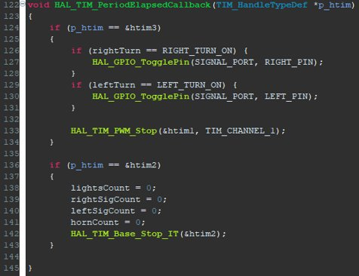
Figure 8: User Input Timing Code

Testing & Results
The car’s functions were tested independently prior to complete integration. To ensure the programming logic met our requirements. We tested the LEDs and horn with push buttons instead of the RC controller and used the Nucleo’s 3.3V power supply instead of the car motors. These substitutions would allow us to just focus on the logic in our code.
Figure 9 came from a demonstration of the functions. A 9V battery is supplying power to the Nucleo. The Nucleo’s own 3.3V supply (car motors) are connected to the various GPIO by push buttons that each represent forward, reverse, left turn, and right turn. The double-click functions were verified for the turn signals, headlights, and horns.
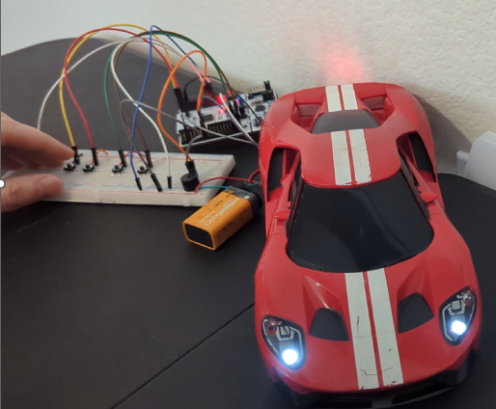
Figure 9: Programming Logic Test
Now that the programming logic was sound, we integrated the RC controller and car motors. The motors introduced bugs in all the functions. The double-clicking action did not work 100% of the time like in the previous test. The LED behavior became unpredictable, and the operator had to persistently double-click the joystick to turn the functions on or off. Considering we had already proven that the Nucleo could read if the motors were running HIGH or LOW and the programming logic was as desired, we made the next logical step was to consider what the motor’s influence was.
See Figure 10. We observed the motor signal once more but this time through an oscilloscope instead of the digital multimeter. The observed signal surprised us because it was not constant HIGH or LOW as we had assumed a DC motor was supposed operate. The signal was periodic and square pulse like.
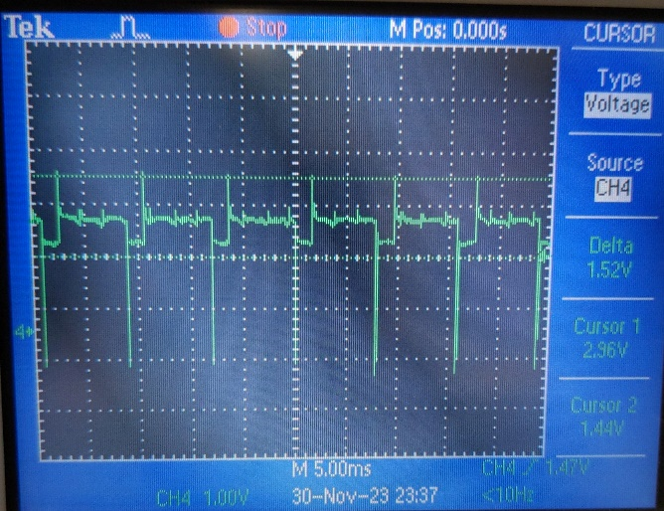 | 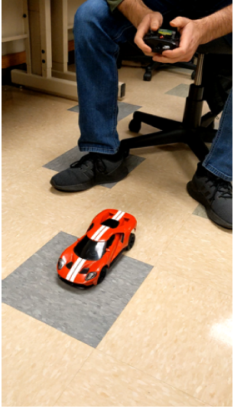
Figure 10: Oscilloscope Readings from DC Motor | Figure 11: Testing with Car Motors

The GPIO pins for each function are set to switch to HIGH on active rising edges of inputs. However, since the DC motor is providing sinusoidal behavior, the operator’s double-clicks cannot reliably update the turn, signal, headlight, and horn counters as intended which accounts for the erratic behavior of LEDs and horn. To resolve the issue, we proposed to remove the rising edges and provide a smoother waveform using a coupling capacitor between the motor leads and the GPIO input pins or an inductor choker. The coupling capacitor acts like a short circuit at high frequencies and inductors ‘choke’ high frequency components from a signal while the dc component is passed.

Conclusion
The project provided valuable experience in going through a product design to build cycle within the context of a team. Our choice to modify the RC car required us to think creatively given that we had to give it more functionality than it was originally designed to do. These added functions to the car were implemented with the end-user’s experience in mind. The implementation required fundamental concepts covered throughout the course such ad timer interrupts, and PWM. The project required us to become more knowledgeable about the Nucleo’s ability particularly on how it absorbs currents and in response we implemented protections to limit risk of damage to the MCU. The coding portion provided a logic challenge with programming controls across multiple GPIO output pins. Valuable lessons we have acquired include 1) researching components before purchasing them, hence the Bluetooth module 2) understanding thoroughly the operation of our components at the start of the project, hence the DC motor signal. In further iterations the design would include the coupling capacitor or choking inductor to smooth the motor signal and provide desirable GPIO inputs.

Reference
[1] STMicroelectronics, Description of STM32L4/L4+ HAL and low-layer drivers. 2021
[2] STMicroelectronics , RM0351 Reference manual STM32L47xxx, STM32L48xxx, STM32L49xxx and STM32L4Axxx advanced Arm®-based 32-bit MCUs. 2021
[3] STMicroelectronics, UM1724 User manual STM32 Nucleo-64 boards (MB1136). 2020
[4] Horowitz, P., & Hill, W. (2022). Reactance and Inductance, Other Capacitor Applications. In The Art of Electronics (pp. 44–54). essay, Cambridge University Press.

